A000-ME-Syria-Tel Halaf-Fertility Idol-Terracotta--6000-5400 BCE

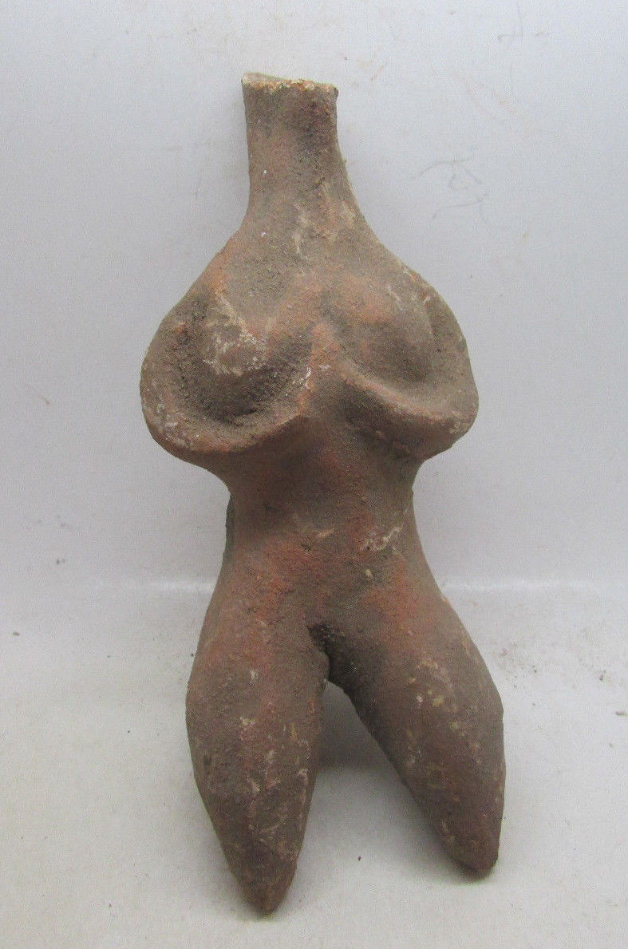 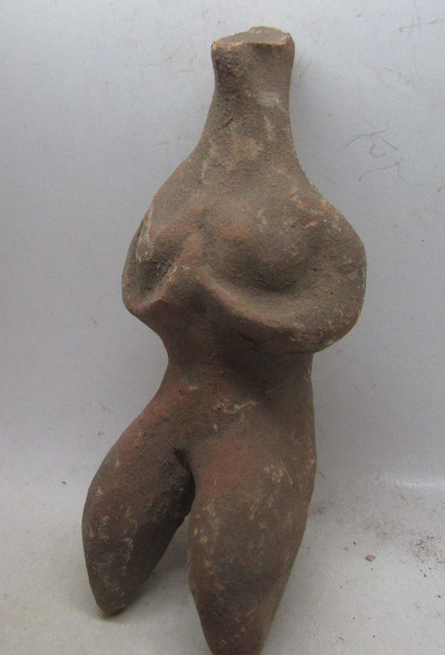

Case no.: 2

Accession Number:

Formal Label: Syria-Tel Halaf-Fertility Idol-Terracotta--6000-5400 BCE

**Display Description:**

**Tell Halaf** ([Arabic](https://en.wikipedia.org/wiki/Arabic_language): تل حلف‎) is an archaeological site in the [Al Hasakah](https://en.wikipedia.org/wiki/Al_Hasakah) governorate of northeastern [Syria](https://en.wikipedia.org/wiki/Syria), near the [Turkish](https://en.wikipedia.org/wiki/Turkey) border, just opposite [Ceylanpınar](https://en.wikipedia.org/wiki/Ceylanpınar). It was the first find of a [Neolithic](https://en.wikipedia.org/wiki/Neolithic) culture, subsequently dubbed the [Halaf culture](https://en.wikipedia.org/wiki/Halaf_culture), characterized by glazed pottery painted with geometric and animal designs. The site, which dates to the 6th millennium BCE, was a [Hittite](https://en.wikipedia.org/wiki/Hittites) ruling city at first and was later the location of the [Aramaean](https://en.wikipedia.org/wiki/Aramaean) city-state of **Guzana** or Gozan in the 10th century BCE. By the end of 9th century BCE the city and its surrounding area was incorporated into the [Assyrian Empire](https://en.wikipedia.org/wiki/Assyrian_Empire).

The **Halaf culture** is a [prehistoric](https://en.wikipedia.org/wiki/Prehistoric) period which lasted between about 6100 BCE and 5100 BCE.[[1]](https://en.wikipedia.org/wiki/Halaf_culture" \l "cite_note-mario-1) The period is a continuous development out of the earlier [Pottery Neolithic](https://en.wikipedia.org/wiki/Neolithic" \l "Neolithic_3_.E2.80.93_Pottery_Neolithic_.28PN.29) and is located primarily in south-eastern [Turkey](https://en.wikipedia.org/wiki/Turkey), [Syria](https://en.wikipedia.org/wiki/Syria), and northern [Iraq](https://en.wikipedia.org/wiki/Iraq), although Halaf-influenced material is found throughout Greater [Mesopotamia](https://en.wikipedia.org/wiki/Mesopotamia).

While the period is named after the site of [Tell Halaf](https://en.wikipedia.org/wiki/Tell_Halaf) in north [Syria](https://en.wikipedia.org/wiki/Syria), excavated by [Max von Oppenheim](https://en.wikipedia.org/wiki/Max_von_Oppenheim) between 1911 and 1927, the earliest Halaf period material was excavated by [John Garstang](https://en.wikipedia.org/wiki/John_Garstang) in 1908 at the site of [Sakce Gözü](https://en.wikipedia.org/wiki/Sakce_Gözü), then in Syria but now part of Turkey.[[2]](https://en.wikipedia.org/wiki/Halaf_culture" \l "cite_note-2) Small amounts of Halaf material were also excavated in 1913 by [Leonard Woolley](https://en.wikipedia.org/wiki/Leonard_Woolley) at Carchemish, on the Turkish/Syrian border.[[3]](https://en.wikipedia.org/wiki/Halaf_culture" \l "cite_note-3) However, the most important site for the Halaf tradition was the site of [Tell Arpachiyah](https://en.wikipedia.org/wiki/Tell_Arpachiyah), now located in the suburbs of [Mosul](https://en.wikipedia.org/wiki/Mosul), [Iraq](https://en.wikipedia.org/wiki/Iraq).[[4]](https://en.wikipedia.org/wiki/Halaf_culture" \l "cite_note-4)

The Halaf period was succeeded by the [Halaf-Ubaid Transitional period](https://en.wikipedia.org/wiki/Halaf-Ubaid_Transitional_period) which comprised the late Halaf (c. 5400-5000 BC), and then by the [Ubaid period](https://en.wikipedia.org/wiki/Ubaid_period).

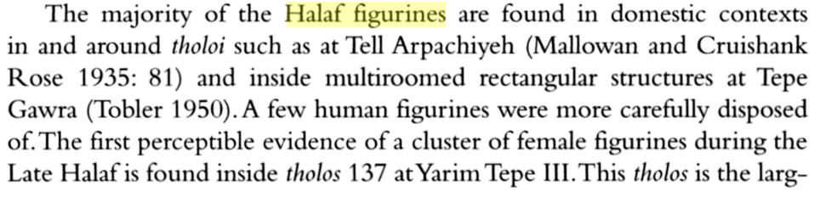

**LC Classification: DS39.T38**

Date or Time Horizon: 6000-5400 BCE

Geographical Area: Northern Syria

**Map:**

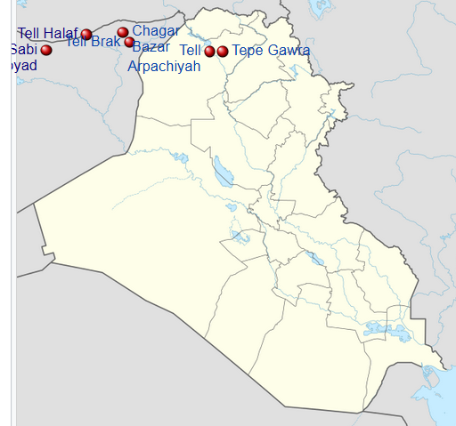

Map of [Iraq](https://en.wikipedia.org/wiki/Iraq) showing important sites that were occupied during the Halaf culture **. After https://upload.wikimedia.org/wikipedia/commons/thumb/8/80/Iraq\_adm\_location\_map.svg/600px-Iraq\_adm\_location\_map.svg.png**

[Tell Halaf](https://en.wikipedia.org/wiki/Tell_Halaf)



[Tell Brak](https://en.wikipedia.org/wiki/Tell_Brak)



[Tell Sabi Abyad](https://en.wikipedia.org/wiki/Tell_Sabi_Abyad)



[Tell Arpachiyah](https://en.wikipedia.org/wiki/Tell_Arpachiyah)



[Tepe Gawra](https://en.wikipedia.org/wiki/Tepe_Gawra)



[Chagar Bazar](https://en.wikipedia.org/wiki/Chagar_Bazar)

**GPS coordinates:** [36.8266°N 40.0396°E](https://tools.wmflabs.org/geohack/geohack.php?pagename=Tell_Halaf&params=36.8266_N_40.0396_E_type:landmark)

Cultural Affiliation:

Medium: terracotta

Dimensions:

Weight:

Condition:

Provenance:

**Discussion:**

**Tell Halaf** ([Arabic](https://en.wikipedia.org/wiki/Arabic_language): تل حلف‎) is an archaeological site in the [Al Hasakah](https://en.wikipedia.org/wiki/Al_Hasakah) governorate of northeastern [Syria](https://en.wikipedia.org/wiki/Syria), near the [Turkish](https://en.wikipedia.org/wiki/Turkey) border, just opposite [Ceylanpınar](https://en.wikipedia.org/wiki/Ceylanpınar). It was the first find of a [Neolithic](https://en.wikipedia.org/wiki/Neolithic) culture, subsequently dubbed the [Halaf culture](https://en.wikipedia.org/wiki/Halaf_culture), characterized by glazed pottery painted with geometric and animal designs. The site, which dates to the 6th millennium BCE, was a [Hittite](https://en.wikipedia.org/wiki/Hittites) ruling city at first and was later the location of the [Aramaean](https://en.wikipedia.org/wiki/Aramaean) city-state of **Guzana** or Gozan in the 10th century BCE. By the end of 9th century BCE the city and its surrounding area was incorporated into the [Assyrian Empire](https://en.wikipedia.org/wiki/Assyrian_Empire).

A formerly unknown transitional culture between the pre-Halaf [Neolithic](https://en.wikipedia.org/wiki/Neolithic)'s era and Halaf's era was uncovered in the [Balikh](https://en.wikipedia.org/wiki/Balikh) valley, at [Tell Sabi Abyad](https://en.wikipedia.org/wiki/Tell_Sabi_Abyad) (the Mound of the White Boy).

Currently, eleven occupational layers have been unearthed in Sabi Abyad. Levels from 11 to 7 are considered *pre-Halaf*; from 6 to 4, transitional; and from 3 to 1, *early Halaf*. No hiatus in occupation is observed except between levels 11 and 10.[[5]](https://en.wikipedia.org/wiki/Halaf_culture" \l "cite_note-akerm-5) The new archaeology demonstrated that Halaf culture was not sudden and was not the result of foreign people, but rather a continuous process of indigenous cultural changes in northern Syria,[[7]](https://en.wikipedia.org/wiki/Halaf_culture" \l "cite_note-7) that spread to the other regions.[[1]](https://en.wikipedia.org/wiki/Halaf_culture" \l "cite_note-mario-1)

**References:**

Akkermans, Peter M. M. G.; Schwartz, Glenn M. (2003). The Archaeology of Syria: From Complex Hunter-Gatherers to Early Urban Societies (c.16,000-300 BC). [*Cambridge University Press*](https://en.wikipedia.org/wiki/Cambridge_University_Press).

Campbell, S. 2000. "The Burnt House at Arpachiyah: A Reexamination" *Bulletin of the American Schools of Oriental Research* no. 318

• • Castro Gessner, G. 2011. "A Brief Overview of the Halaf Tradition" in Steadman, S and McMahon, G (eds.) *The Oxford Handbook of Ancient anatolia*. Oxford: Oxford University Press. pp. 780

• • Castro Gessner, G. 2011. "A Brief Overview of the Halaf Tradition" in Steadman, S and McMahon, G (eds.) *The Oxford Handbook of Ancient anatolia*. Oxford: Oxford University Press. pp. 781

Liverani, Mario (2013). The Ancient Near East: History, Society and Economy. [*Routledge*](https://en.wikipedia.org/wiki/Routledge).

• • Maria Grazia Masetti-Rouault; Olivier Rouault; M. Wafler (2000). [*La Djéziré et l'Euphrate syriens de la protohistoire à la fin du second millénaire av. J.C, Tendances dans l'interprétation historique des données nouvelles, (Subartu) - Chapter : Old and New Perspectives on the Origins of the Halaf Culture by Peter Akkermans*](https://www.academia.edu/564231/Old_and_New_Perspectives_on_the_Origins_of_the_Halaf_Culture). pp. 43–44.

• • John L. Brooke (2014). *[Climate Change and the Course of Global History: A Rough Journey](https://books.google.nl/books?id=O9TSAgAAQBAJ&pg=PA204" \l "v=onepage&q&f=false)*. p. 204.

• • Georges Roux (1992). *[Ancient Iraq](https://books.google.nl/books?id=klZX8B_RzzYC&pg=PT101" \l "v=onepage&q&f=false)*. p. 101.

• • Susan Pollock; Reinhard Bernbeck (2009). *[Archaeologies of the Middle East: Critical Perspectives](https://books.google.nl/books?id=bRUMQb_1uKcC&pg=PA190" \l "v=onepage&q&f=false)*. p. 190.

• • Peter M. M. G. Akkermans, Glenn M. Schwartz (2003). *[The Archaeology of Syria: From Complex Hunter-Gatherers to Early Urban Societies (c.16,000-300 BC)](https://books.google.nl/books?id=_4oqvpAHDEoC&pg=PA157" \l "v=onepage&q&f=false)*. p. 157.

• Robert J. Speakman; Hector Neff (2005). *[Laser Ablation ICP-MS in Archaeological Research](https://books.google.nl/books?id=jcOqDcDrNt4C&pg=PA128" \l "v=onepage&q&f=false)*. p. 128

# Order details

Printer friendly page

## Sales order

Sold by [coinauction12](http://myworld.ebay.com/coinauction12) ( [5855](http://feedback.ebay.com/ws/eBayISAPI.dll?ViewFeedback&userid=coinauction12) )

+ Show additional actions

### Delivery package 1 of 1

Estimated delivery Friday, May 20, 2016 -Thursday, May 26, 2016

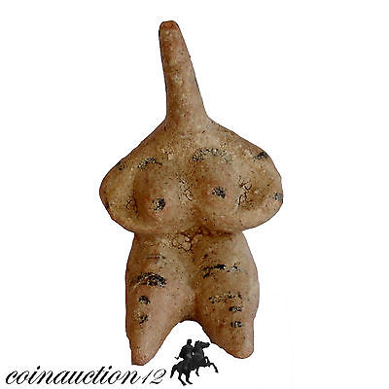

#### [MUSEUM QUALITY TERRACOTTA TEL HALF FEMALE STATUE IDOL 6100-5400 BC](http://www.ebay.com/itm/391452373433)

|  |  |
| --- | --- |
| **Item price** | GBP 65.00 |
| **Quantity** | 1 |
| **Item number** | 391452373433 |
| **Shipping service** | Royal Mail International Signed |

[Contact seller](http://contact.ebay.com/ws/eBayISAPI.dll?FindAnswers&frm=3998&iid=391452373433&redirect=0&requested=coinauction12)

[Return item](http://return.ebay.com/ws/eBayISAPI.dll?ResolveReturn&eventName=viewSelectedItem&TransactionId=0&ItemId=391452373433)

## Shipping address

Ralph J Coffman Jr

149 Atlantic Ave

Swampscott MA 01907-2427

United States

## Order total

|  |  |
| --- | --- |
| **Subtotal** | GBP 65.00 |
| **Shipping** | GBP 9.99 |

**Total**

GBP 74.99

[View PayPal transaction](http://payments.ebay.com/ws/eBayISAPI.dll?UnifiedCheckoutSummaryRedirect2PP&itemid=391452373433&transId=0&buyerorseller=0)

Order placed on

Monday, May 16, 2016

Payment method

PayPal

Payment date

Monday, May 16, 2016